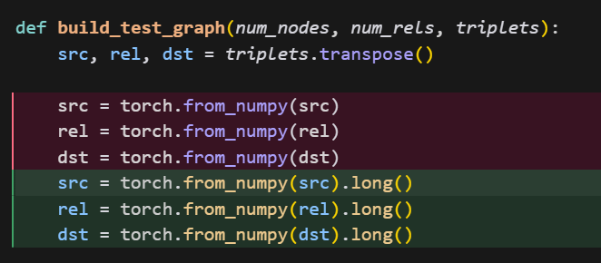
Changes
- Out of memory issue: reduced the test triples from all to 200k to prevent oom
- Made compatible with gpu to run on ruch

Comparable results with paper (results a bit lower probably due to not using the complete triplets for the test graph)
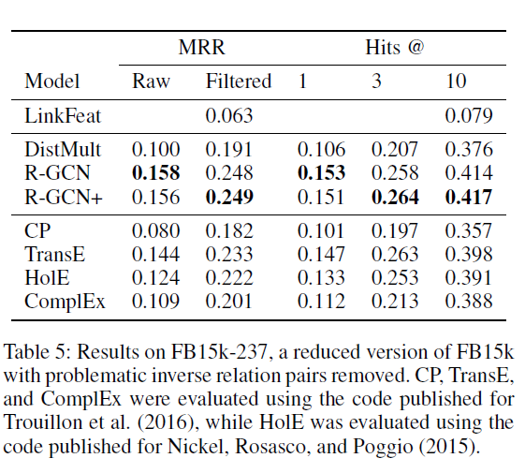
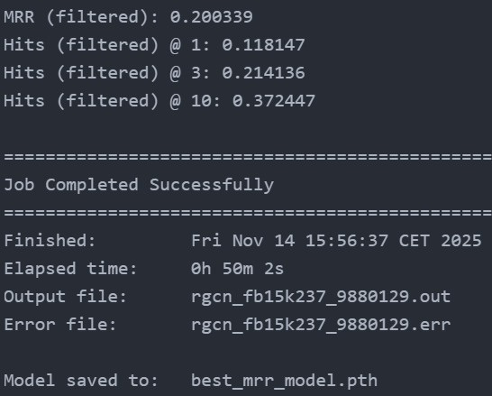
Main issue: reduced test graph size
You're using 200,000 triplets out of 272,115 (~73.5%). This leads to:
- Sparse graph structure: some entities have fewer or missing connections
- Lower-quality embeddings: RGCN aggregates neighbor information; fewer edges means less information
- Random sampling: may miss important edges
Impact on results
- Full graph (272k triplets): best embeddings → higher MRR/Hits@K
- 200k triplets (~73%): incomplete graph → lower embeddings → lower MRR/Hits@K
- Typical impact: 1–3% lower MRR, 2–5% lower Hits@K

Summary of changes and reasons:

Summary of changes
1. Fixed `one_hot` LongTensor error (utils.py)
- Problem: `F.one_hot()` requires LongTensor, but `torch.from_numpy()` doesn't guarantee it
- Change: Added `.long()` conversion in `build_test_graph()`
- Location: `utils.py`
2. Fixed out-of-memory (OOM) error
- Problem: All 272k training triplets → 544k edges → ~20GB memory needed
- Changes:
- Added `max_edges` parameter to `build_test_graph()` to limit triplets
- Added `--test-graph-size` CLI argument (default: 200,000)
- Added GPU cache clearing (`torch.cuda.empty_cache()`)
- Locations:
- `utils.py` lines 143-176: `build_test_graph()` with sampling
- `main.py` lines 138-145: CLI argument
- `main.py` lines 25-38, 42-58: Cache clearing in `valid()` and `test()`

3. Added GPU support for validation/test
- Problem: Model moved to CPU before validation; test graph never moved to GPU
- Changes:
- Removed `model.cpu()` before validation
- Added GPU device movement in `valid()` and `test()`
- Added `use_cuda` parameter to both functions
- Locations:
- `main.py` lines 23-40: `valid()` with GPU support
- `main.py` lines 42-58: `test()` with GPU support
- `main.py` lines 99-104: Removed CPU transfer, added cache clearing

4. Fixed GPU tensor to NumPy conversion errors
- Problem: GPU tensors can't convert to NumPy directly; need CPU first
- Changes: Added CPU transfer before NumPy conversion, then move back to GPU if needed
- Locations: `utils.py` lines 209-216, 244-249, 231-232, 266-267
```python
# Before: delete_entity_index.numpy() # ❌ Fails on GPU
# After:
if delete_entity_index.is_cuda:
delete_entity_index_np = delete_entity_index.cpu().numpy() # ✅
else:
delete_entity_index_np = delete_entity_index.numpy()
```

5. Updated SLURM script (run_rgcn.sh)
- Changes:
- Added `PYTORCH_CUDA_ALLOC_CONF=expandable_segments:True` for memory management
- Added explicit `--test-graph-size 200000` argument
- Added informative messages about memory settings
- Added torch-scatter installation checks
- Location: `run_rgcn.sh` lines 220-222, 240, 212-216

Why these changes

| Change | Reason |
|--------|--------|
| LongTensor conversion | PyTorch's `one_hot()` requires integer tensors of type LongTensor |
| Test graph size limiting | Prevents OOM by reducing memory from ~20GB to ~15GB |
| GPU cache clearing | Frees unused GPU memory between training and validation |
| GPU support for validation | Uses GPU for validation/test instead of slower CPU |
| CPU transfer for NumPy | NumPy is CPU-only; GPU tensors must be copied to CPU first |
| SLURM script updates | Ensures proper environment setup and memory management |

Result

- Runs on GPU without OOM errors
- Uses 200k triplets by default (adjustable)
- Handles GPU/CPU tensor conversions correctly
- Properly manages GPU memory with cache clearing
- Works with SLURM on A100 GPUs

